What have we covered this week (3/3/2025) - (3/10/2025)

We have go through the site including Product Pages and it’s subpages by making sure that we address the following:

1. Responsive Issues
2. Spacing issues
3. Overall site consistency

**Scope**

In this scope, We have covered the following Pages:

**1. Remaining Product Header Pages**

* Payment Page
* Insurance Page

**2. Resource Header Pages**

* Resource Center
* Guides
* Company News
* Customer Stories

The Following **Before** and **After** picture represents the state of the site before and how it was refined after going through Q.A drive:

## **Before**

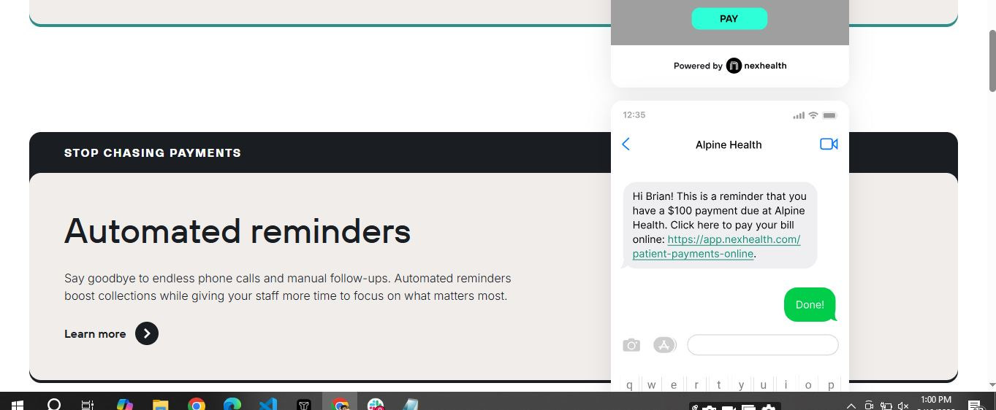

## **After**

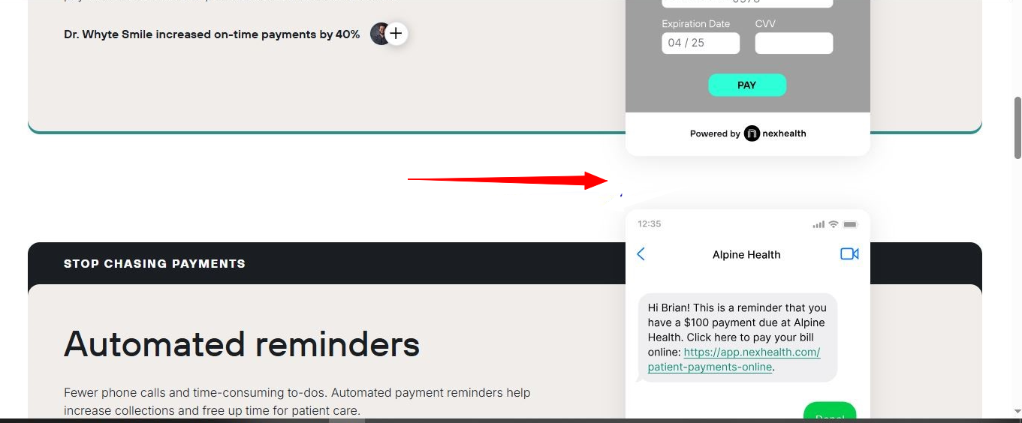

## **Before**

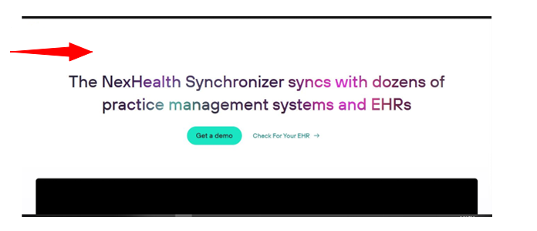

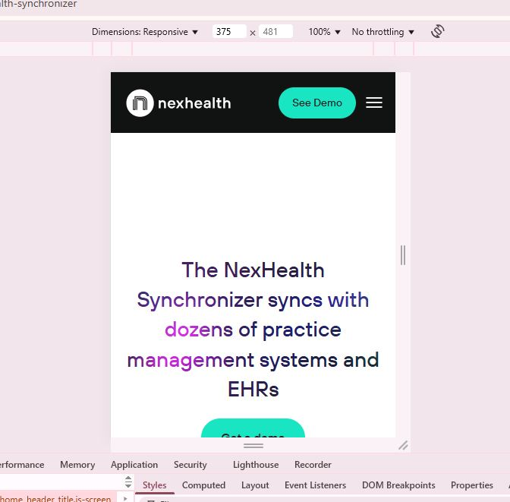

## **After**

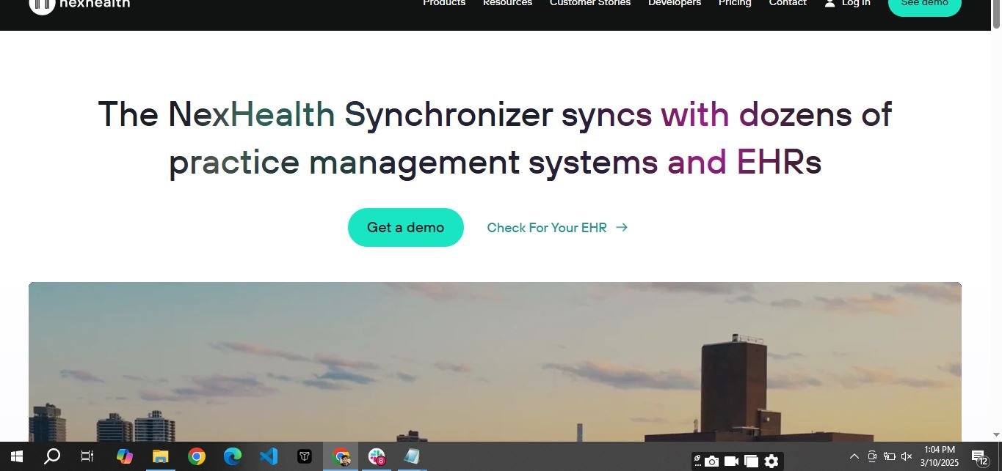

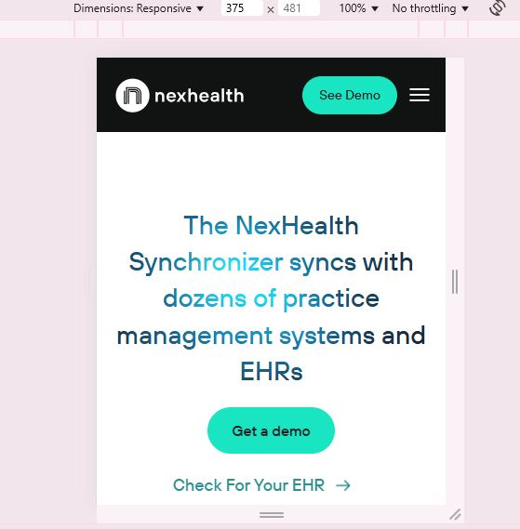

## **Before**

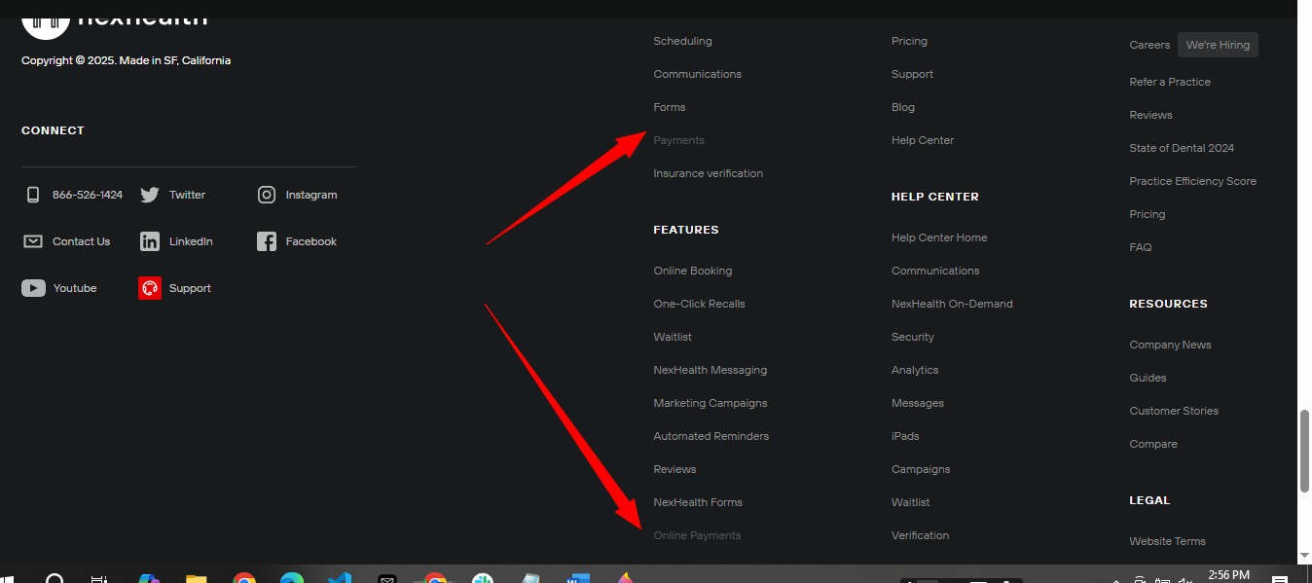

## **After**

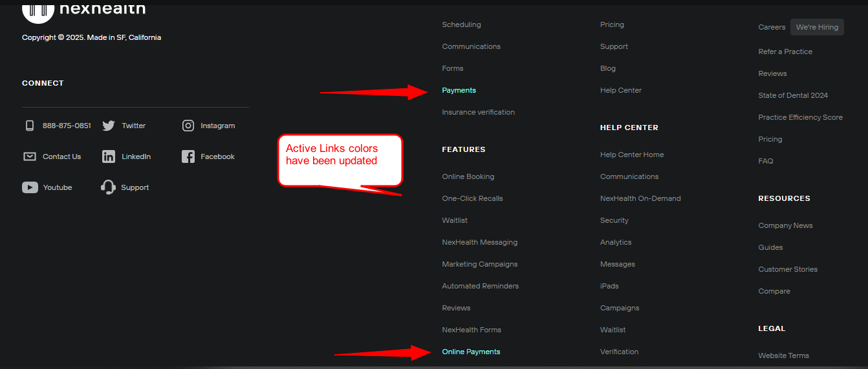

## **Before**

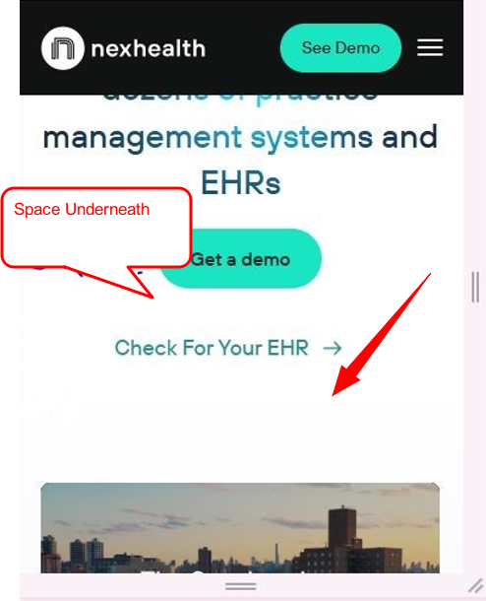

## **After**



## **Before**

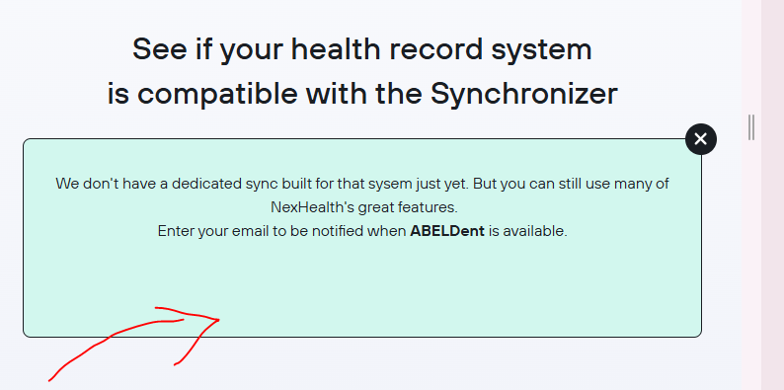

## **After**

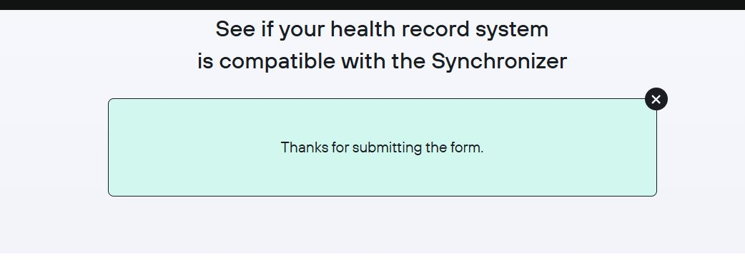

## **Before**

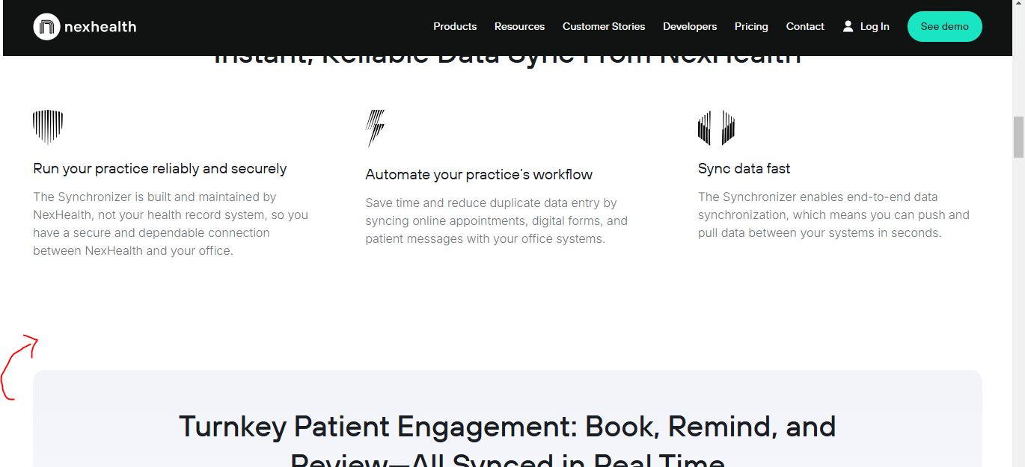

## **After**

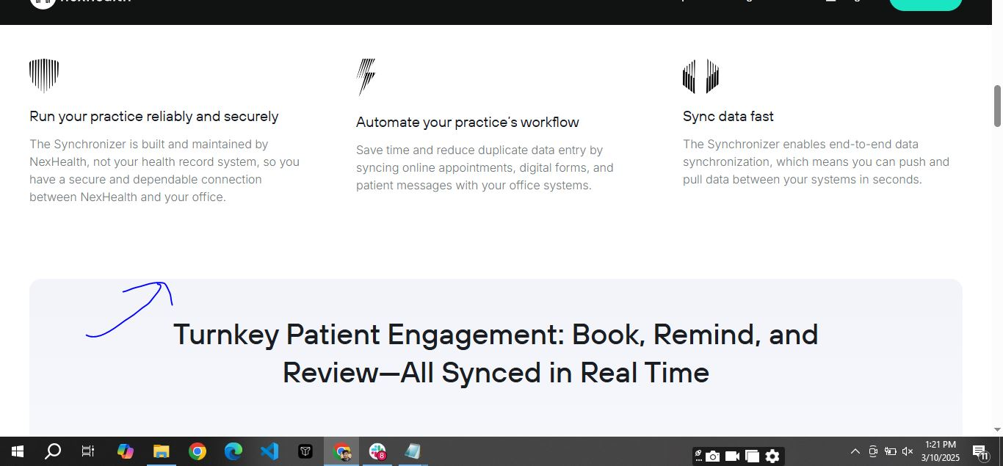

## **Before**

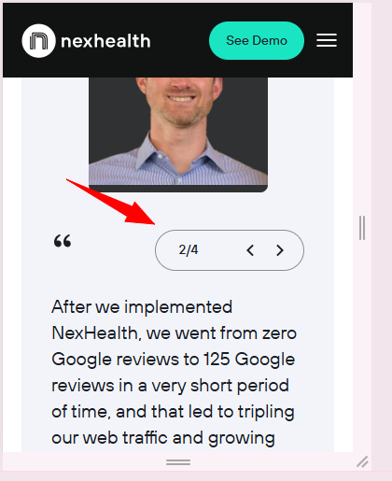

## **After**

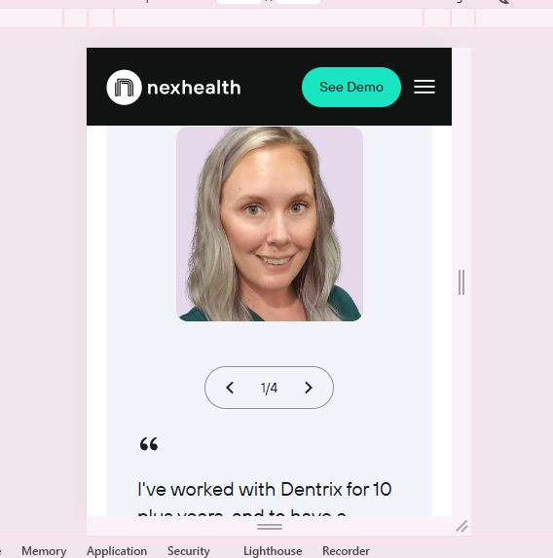

## **Before**

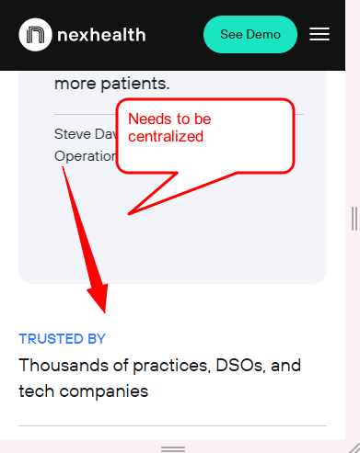

## **After**

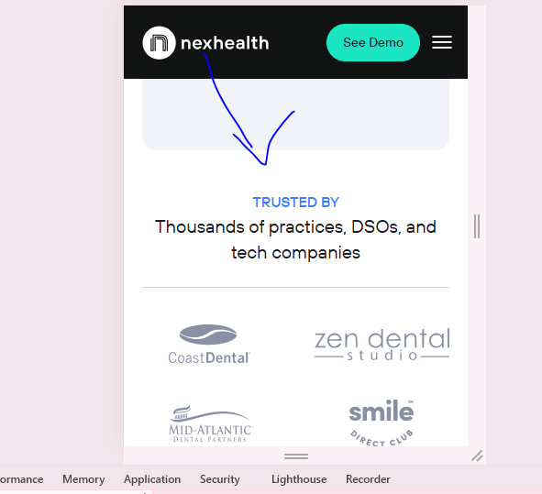

## **Before**

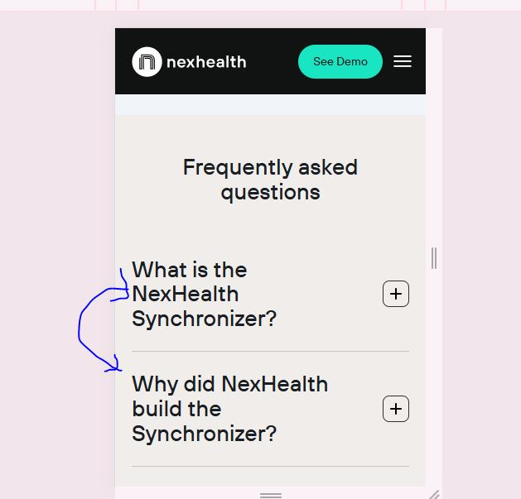

## **After**

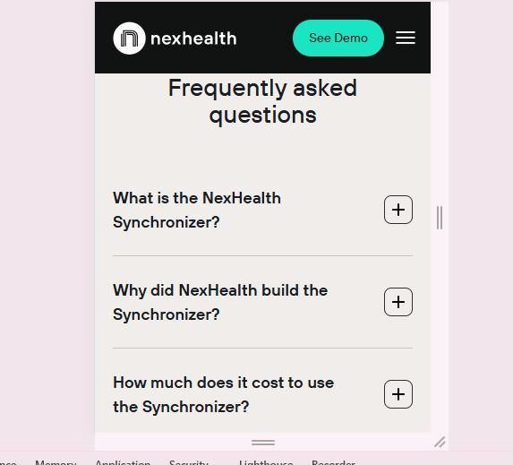

## **Before**

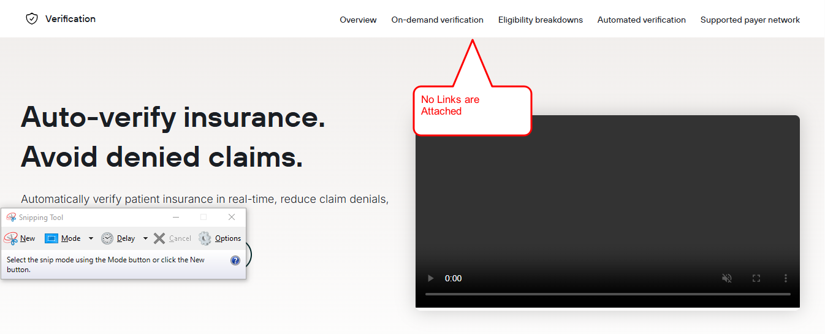

## **After**

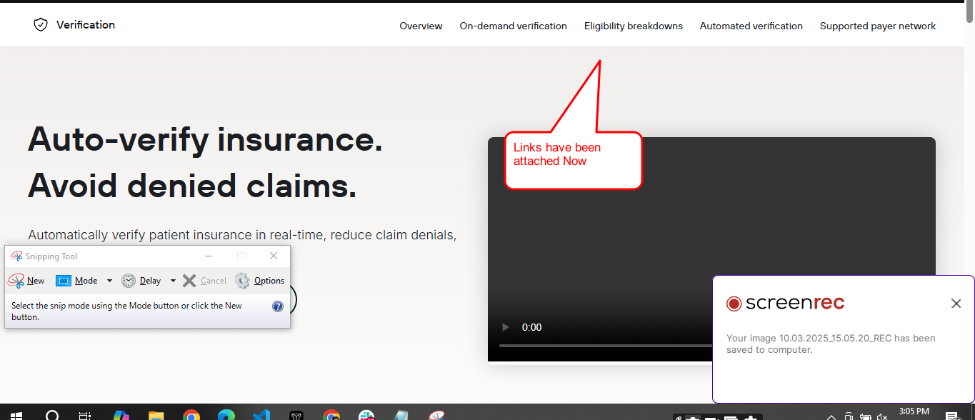

## **Before**

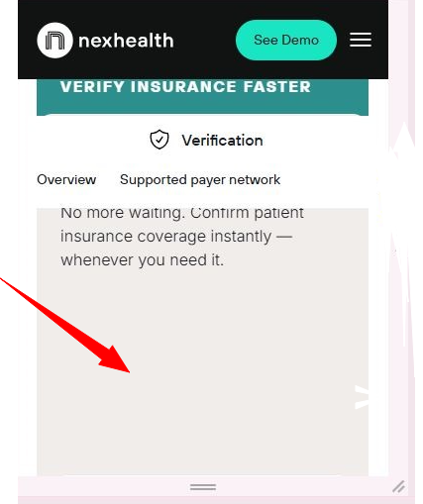

**After**

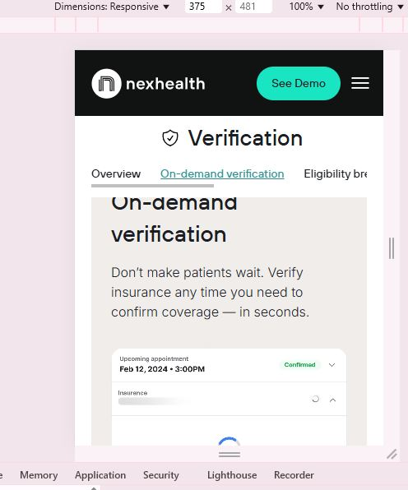

## **Before**

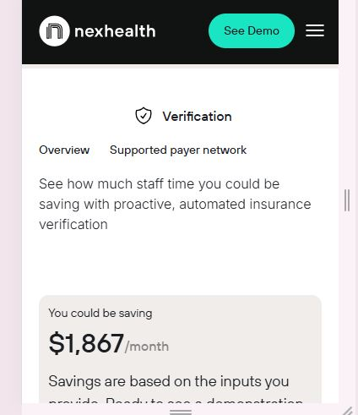

**After**

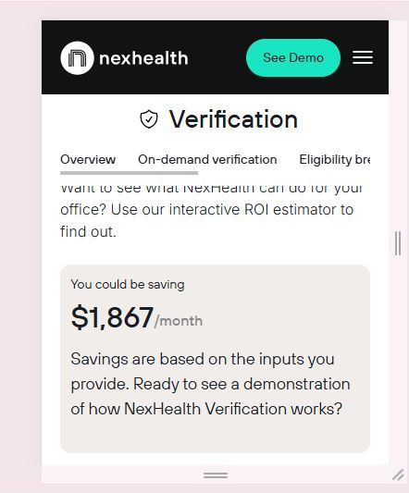

## **Before**

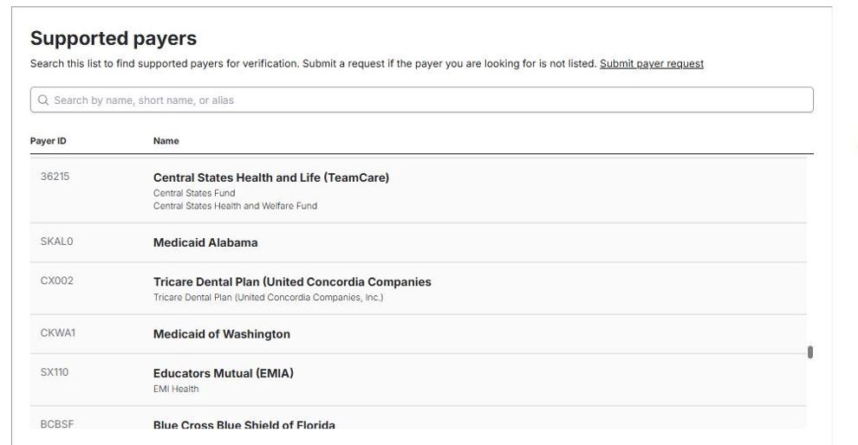

## **After**

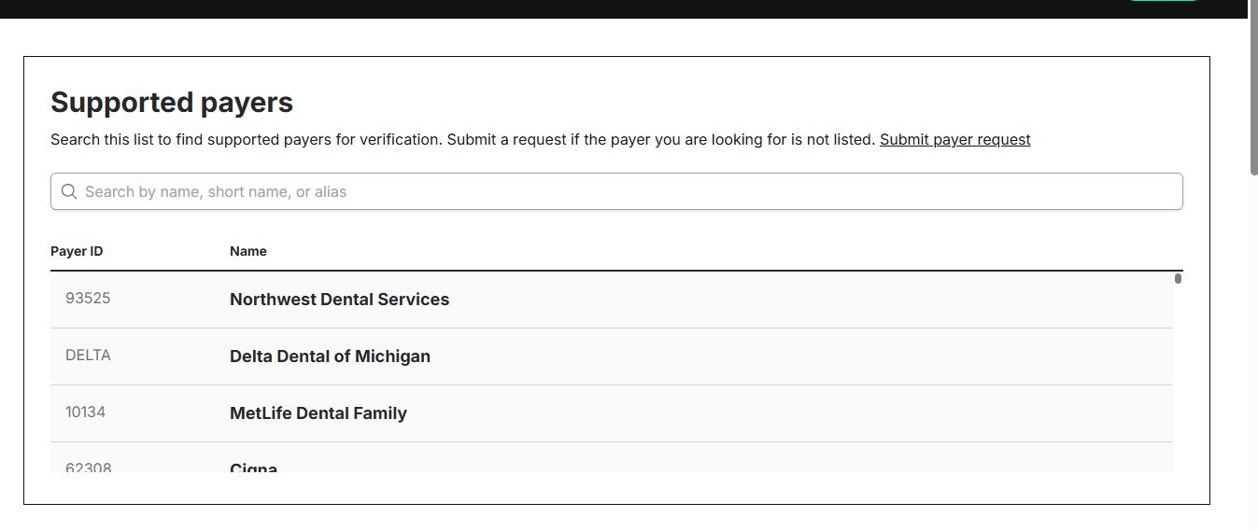

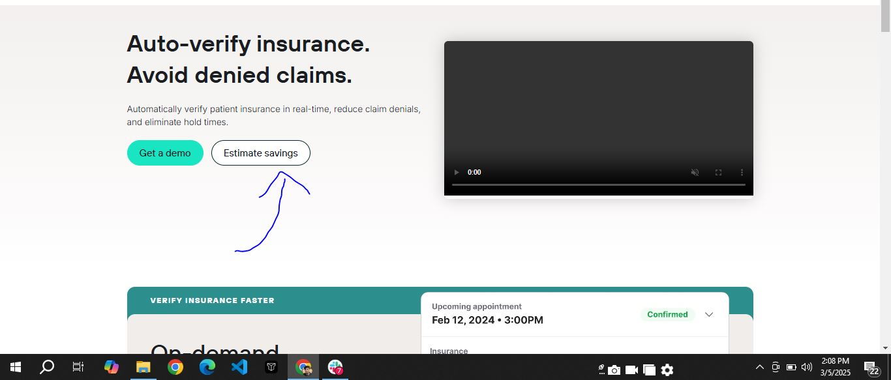

**Before**

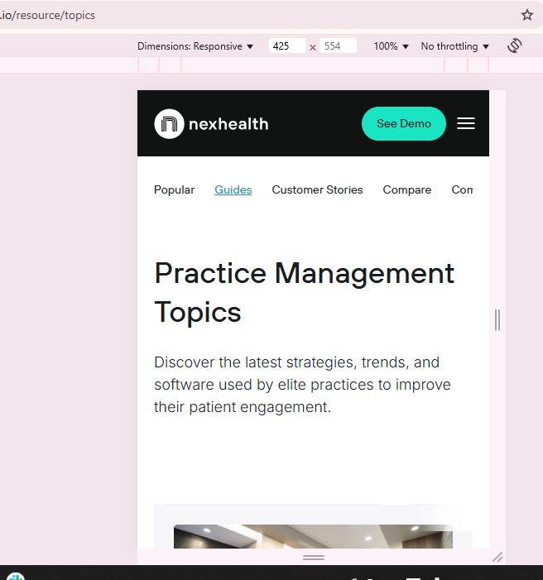

## **After**

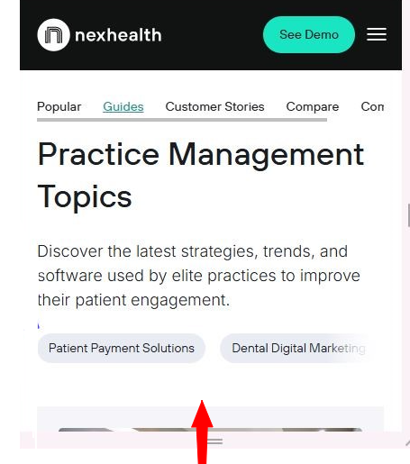

## **Before / After**

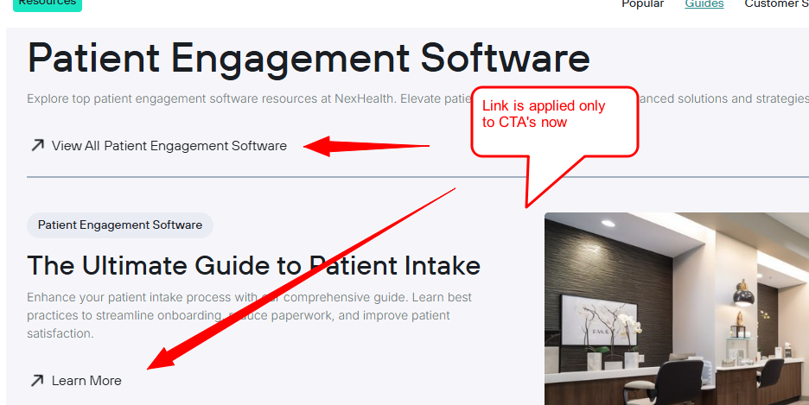

**Before**

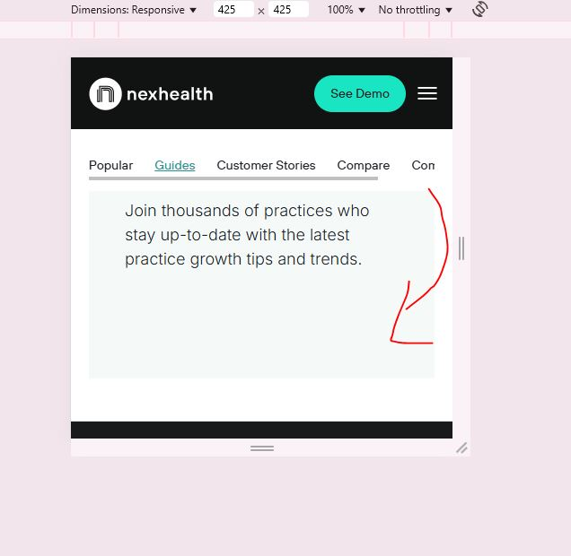

**After**

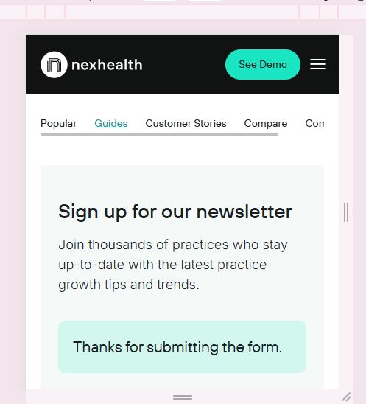

## **Before**

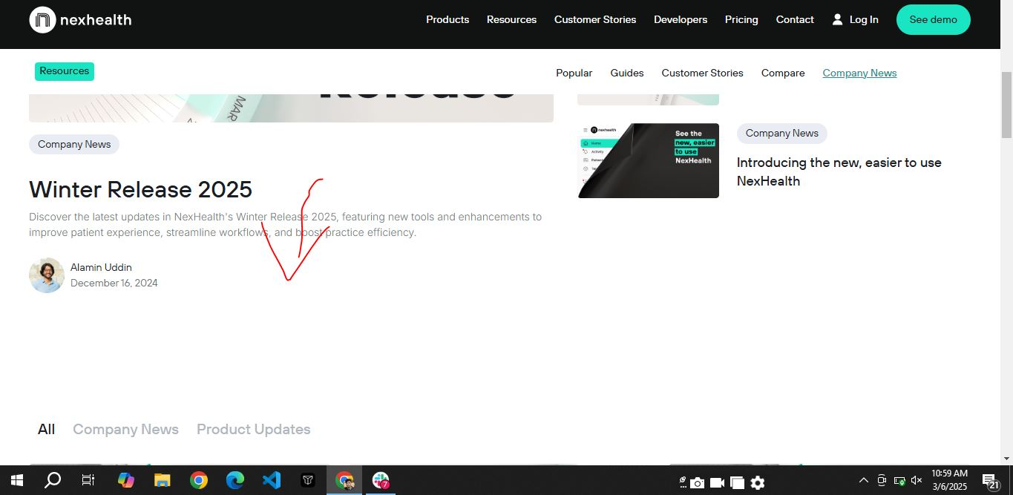

## **After**

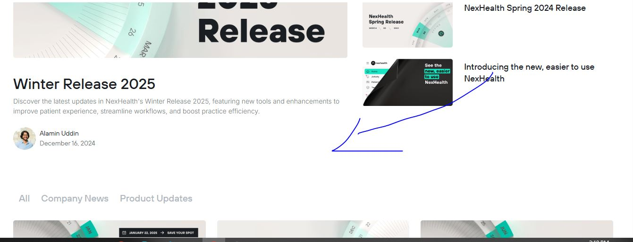

## **Before**

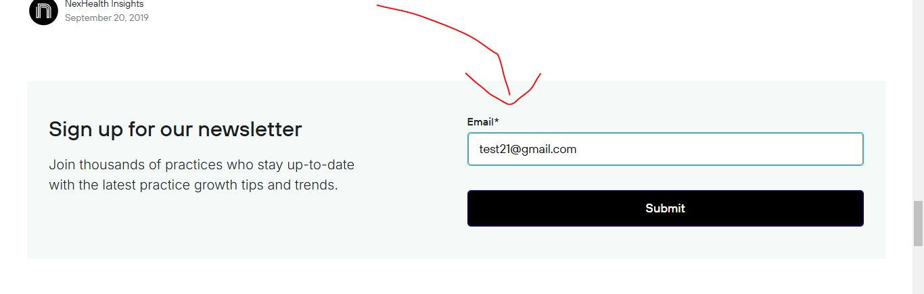**After**

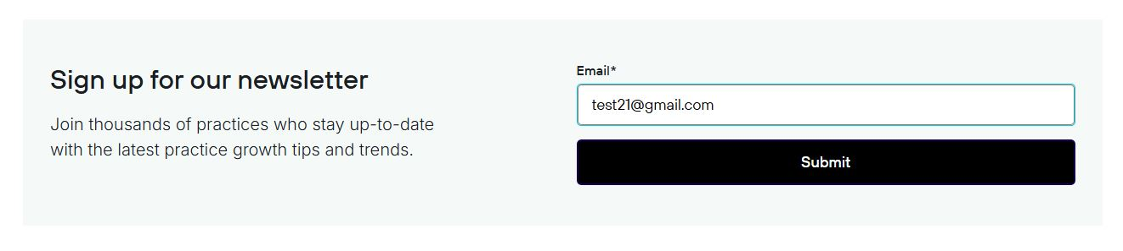

Scope of the Week (3/10/2025) - (10/10/2025)

We are addressing the **Responsiveness** of the overall site which includes:

1. Spacing Issues
2. Mobile Responsiveness
3. Browser compatibility
4. Consistency of Sections & Images

We will be focused on covering the following pages of the site:

**1. Resource Center Helpful Pages**

* Help Center
* Careers
* Integrations
* Culture
* Api
* FAQs

**2. Developer Pages**

* Pricing
* Use Cases
* How it Works
* Get API access

**NOTE:**

If the client approves, then we will shift those pages on live which have previously worked on. In that case, we will reduce the above scope a little bit.

—-----------------------------------------------------------------------------------------------------------